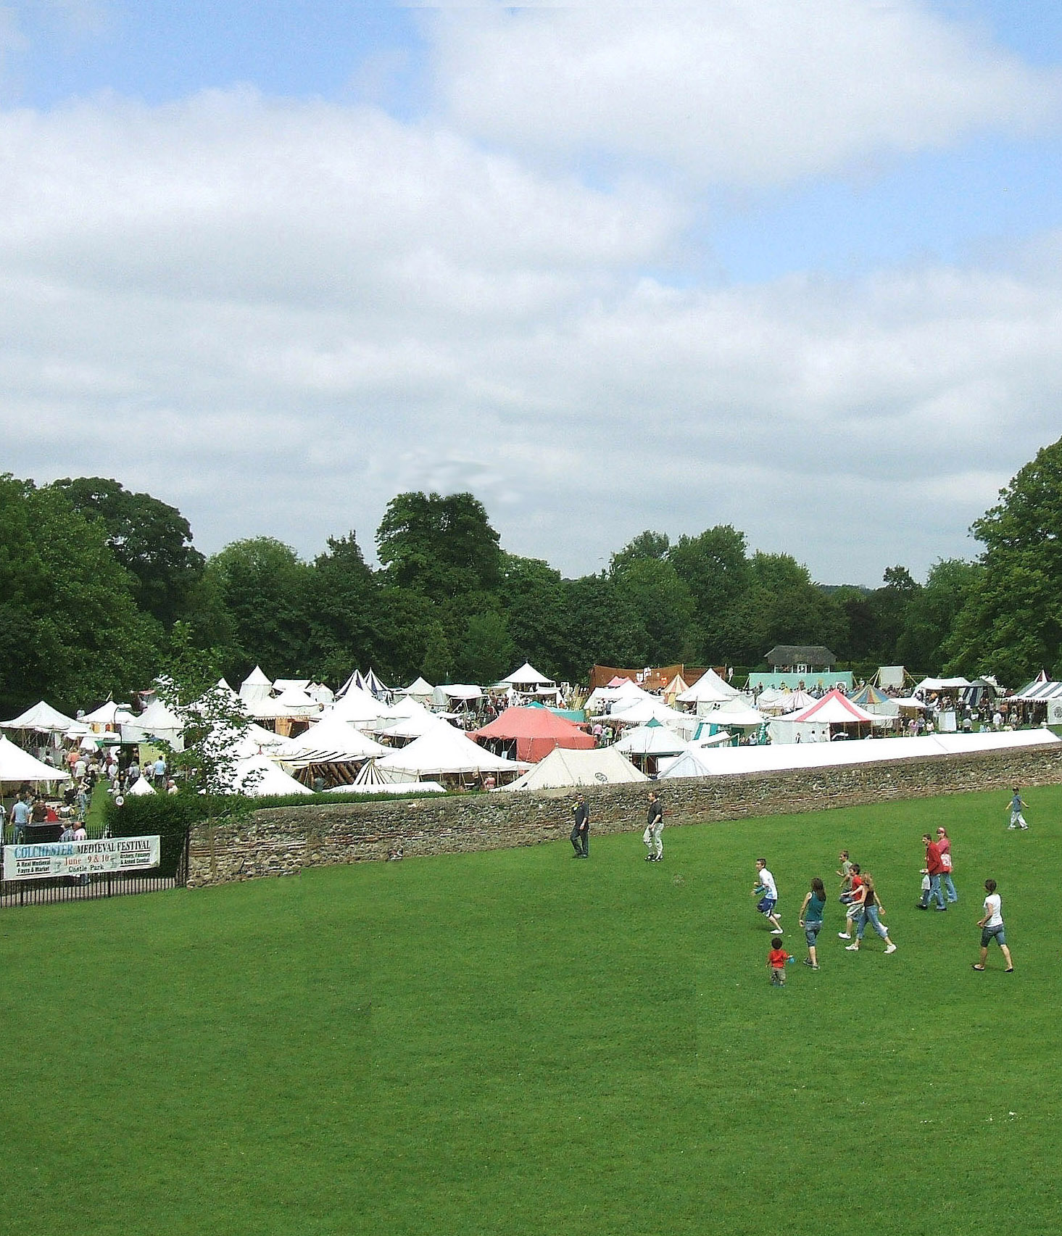

The Colchester Medieval Festival

featuring The Oyster Fayre Market

June 6th & 7th 2015

Lower Castle Park ~ 10.00 to 5.00

“The finest market setting in the land”

Archery, Falconry, Armed Combat *
Storytellers, Music, Singing, Dancing,
Puppetry, Craftsmen, Theatre & Players
Shop at the unique Medieval Merchants’ Market
Eat & Drink at our fine Food Court & Beer Tent
Admission: £8 under 14 £4 concessions £5
Latest news: www.ColchesterMedievalFestival.co.uk
* The weekend programme & entertainment may vary without prior notice

